**STUDENT NAME:  *Carl Broker***

**Lab11A Output**

1. Screen shot of S3 ratings-<some random number>/ job folder

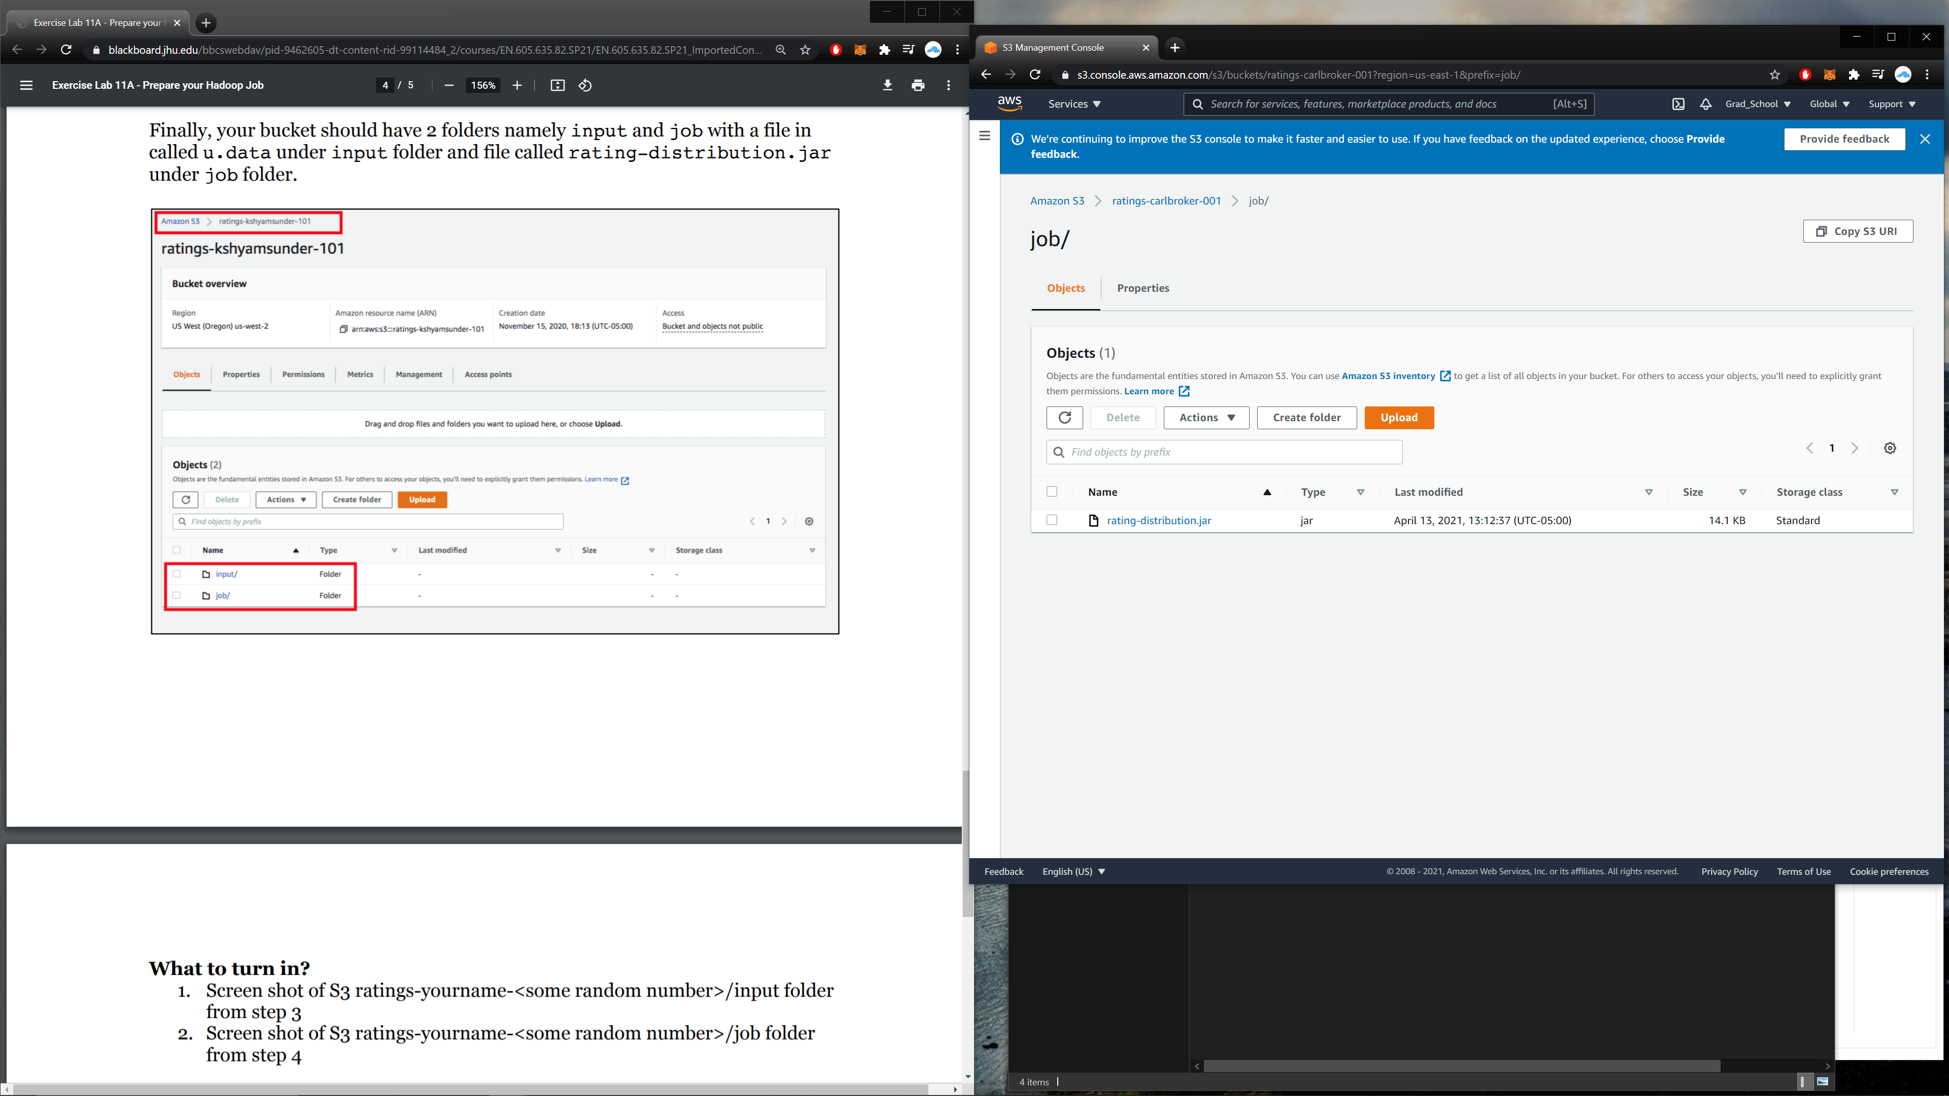

1. Screen shot of S3 ratings-<some random number>/input folder

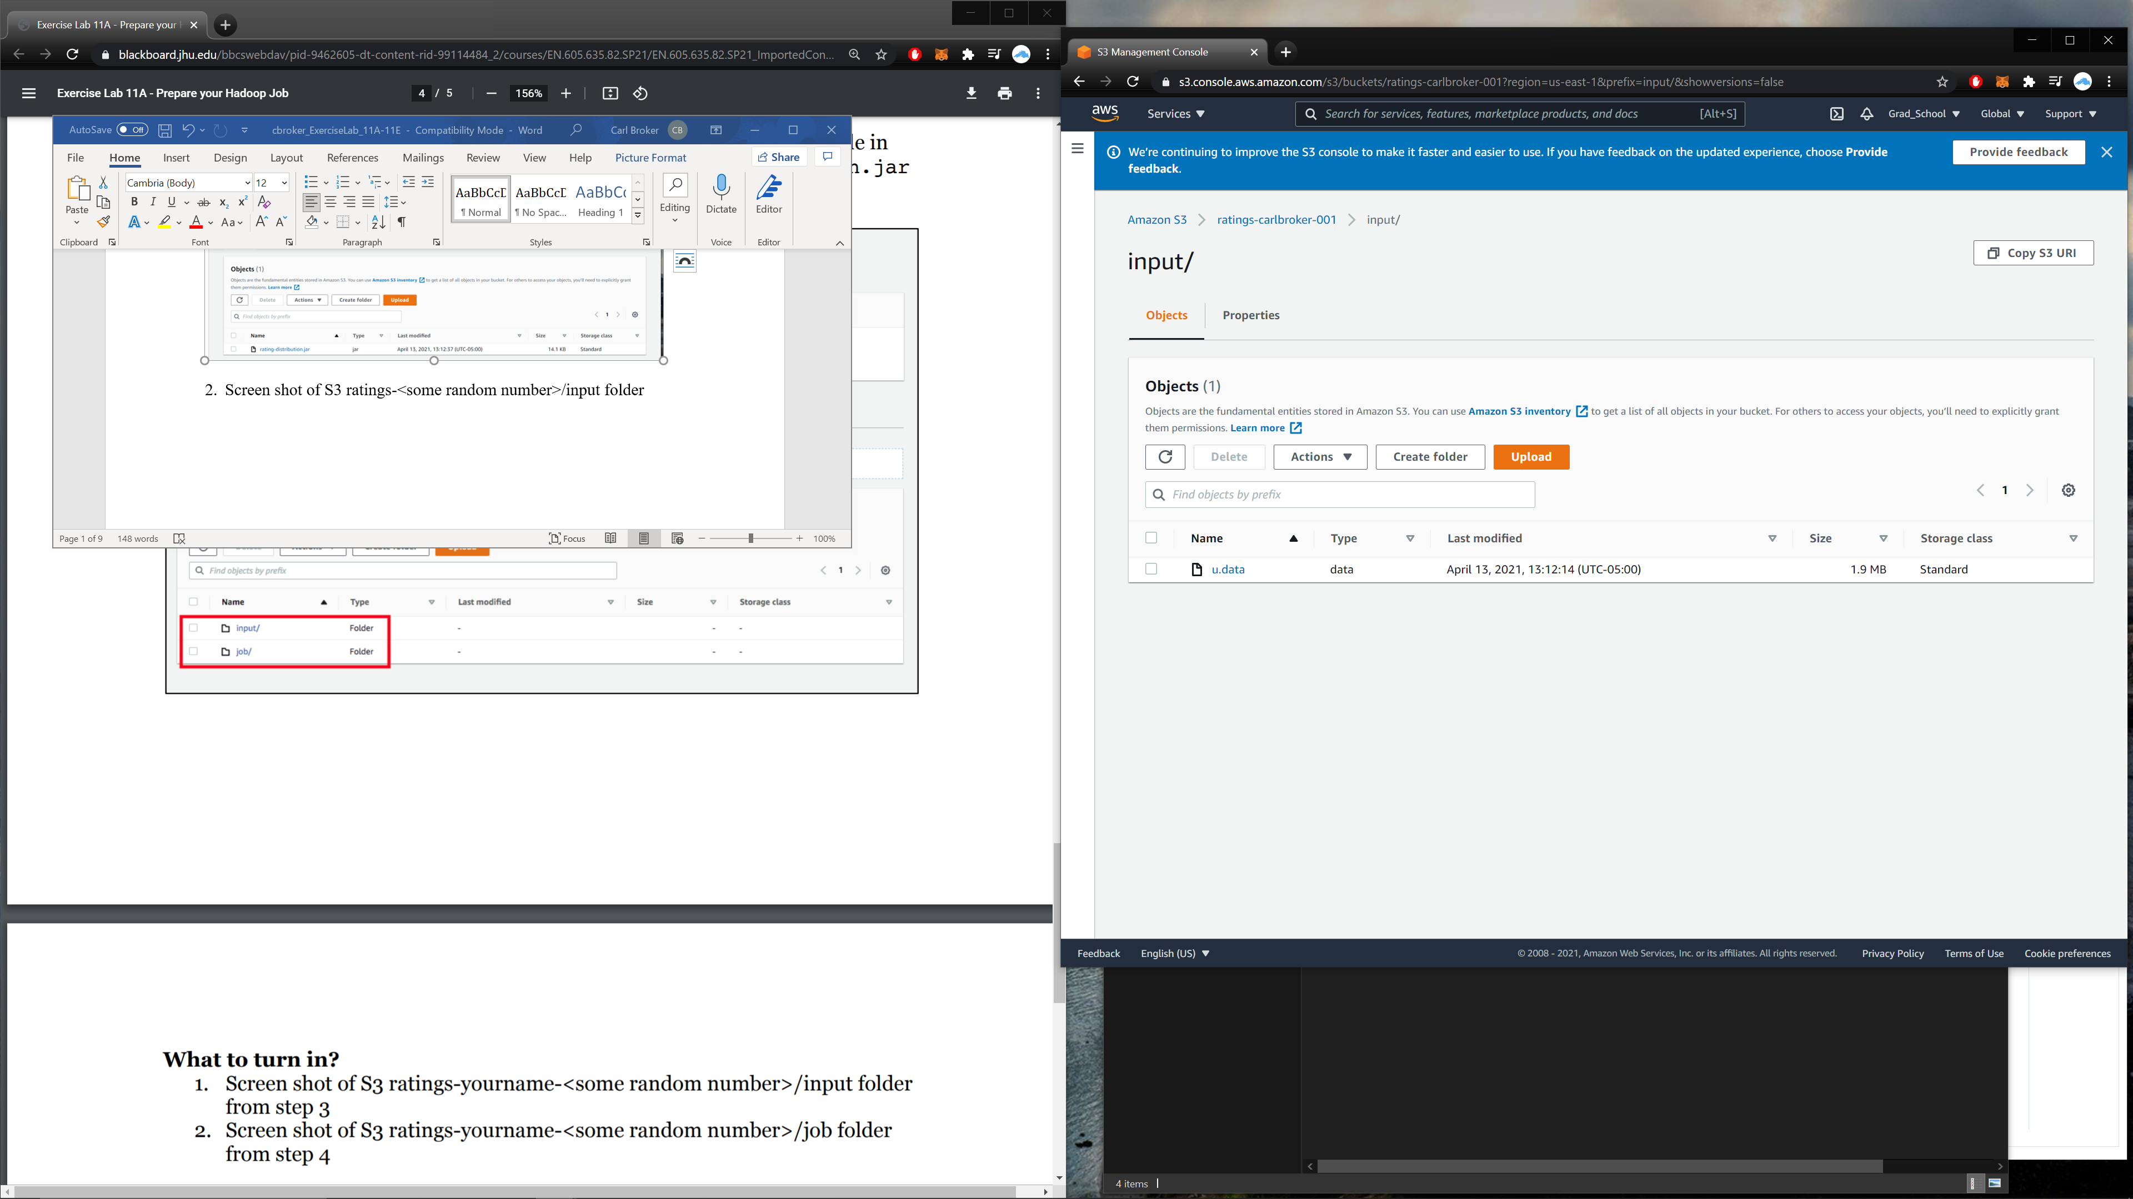

**11 B Output**

1. Screen shot of cluster details once it is launched.

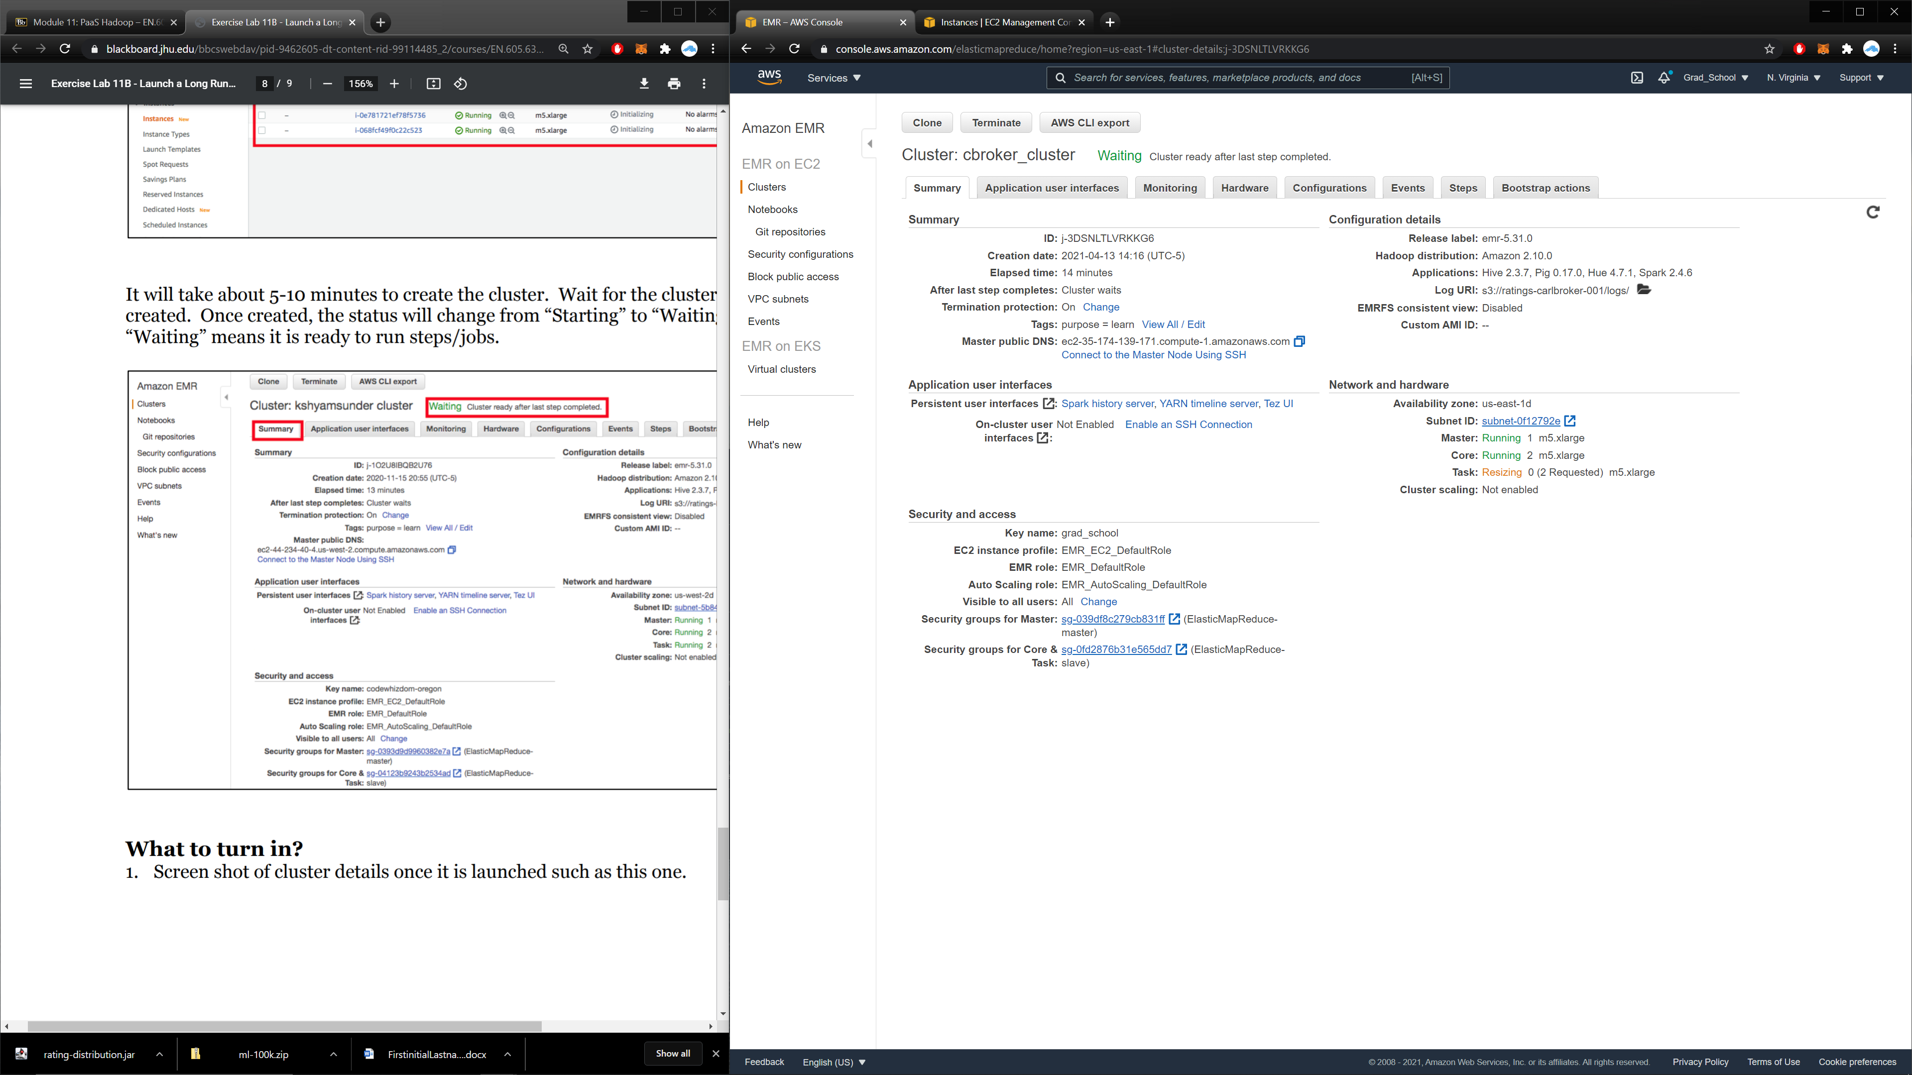

2. Screen shot ec2 instance list – display only the machines associated with the EMR cluster

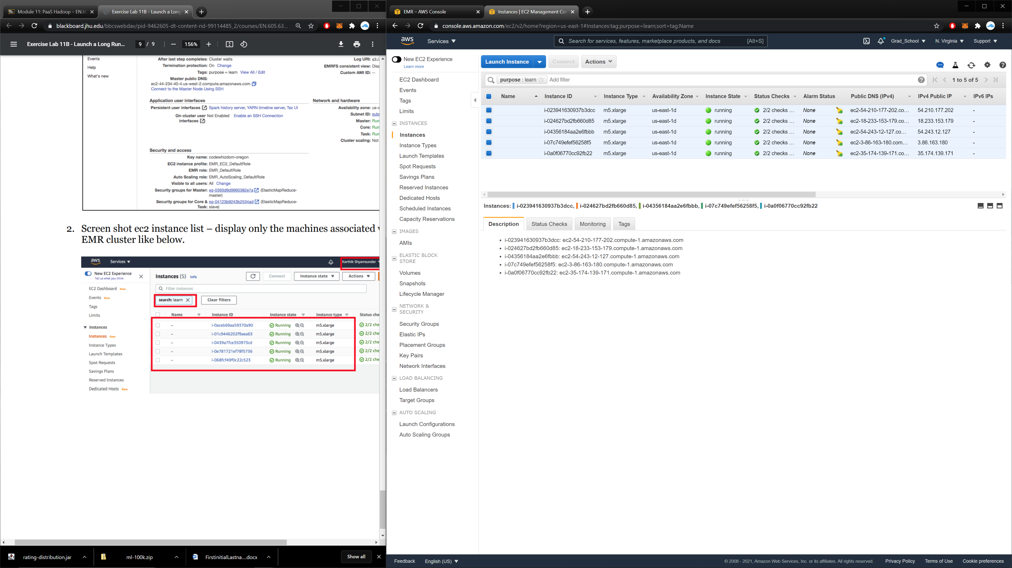

**11C Output**

1. Once the ratings step is run successfully, screenshot of the Events (just like the screenshot in step 2)
2. Screen shot of S3 output folder (just like the screenshot in step 3)
3. Content from the part-r00000 file

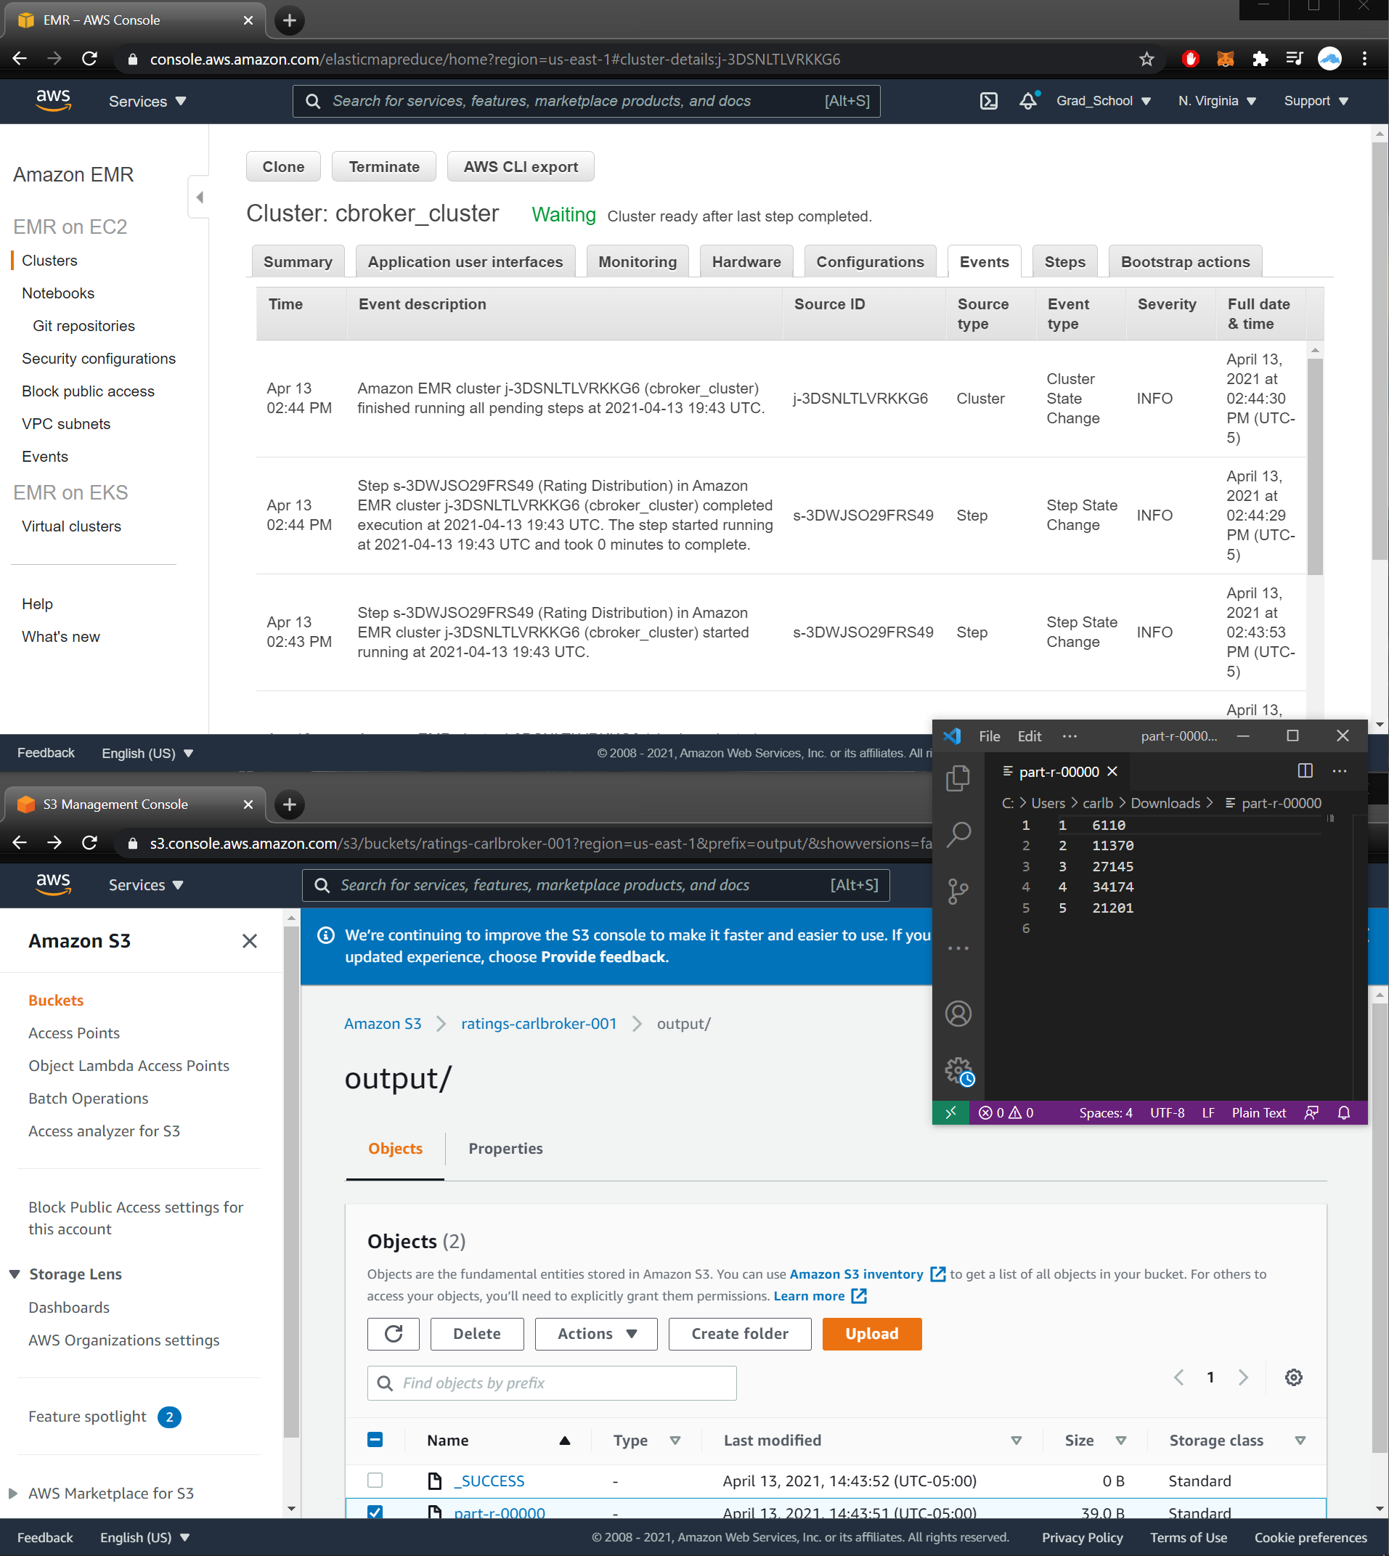

**11D Output**

1. Screen shot of cluster Hardware section while resizing is taking place or after resize has taken place.

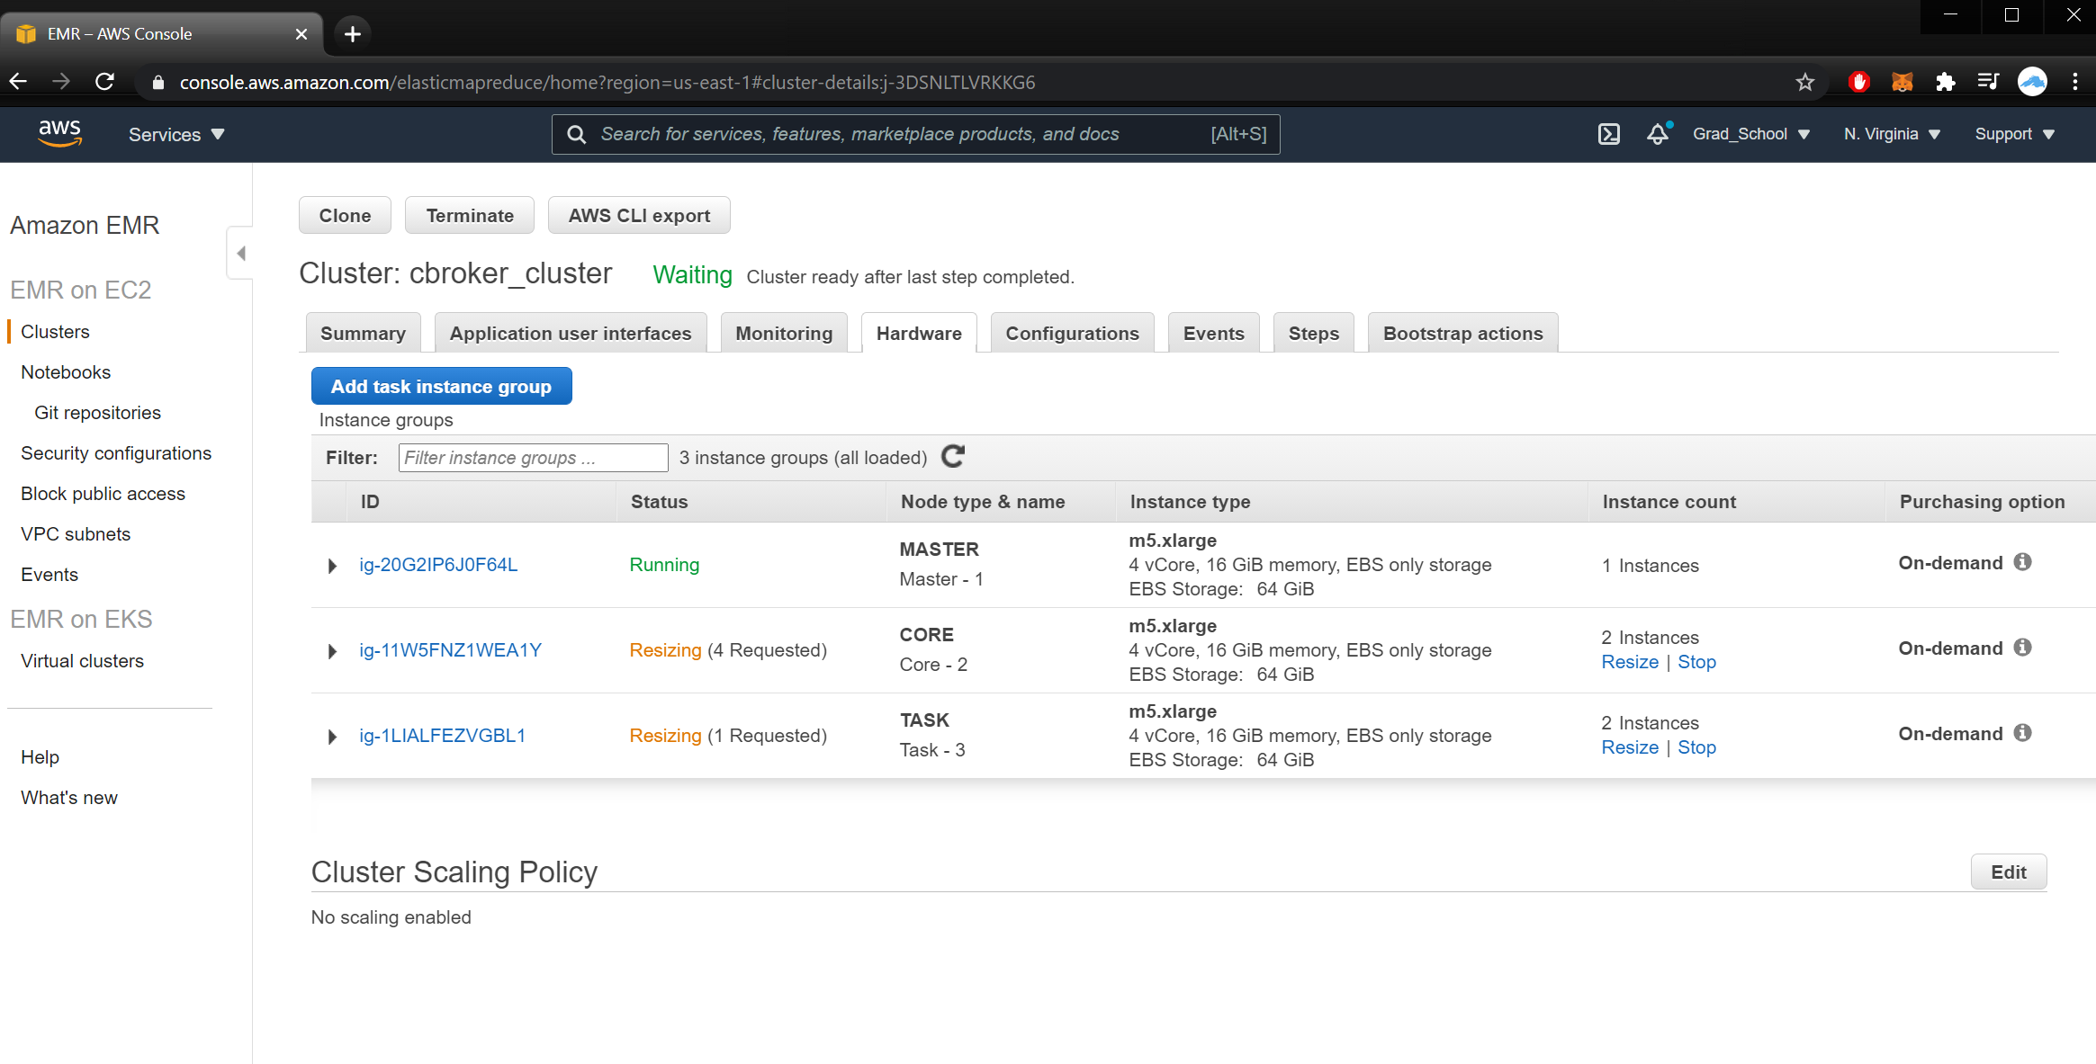

**11E Output**

1. What happened when you killed one of the slave nodes? Explain.

When I killed a slave node, the EMR reinstated a new EC2 to replace the one I ‘accidently’ terminated.

1. What happened when you killed the master node? What is the final status of the cluster. Explain.

When I killed the master node, the EMR cluster status stated, ‘The master node was terminated by user”. This makes sense because I did terminate the node on the EC2 dashboard. I’m glad to see that I was notified on the EMR end.